OUR TOP 10 PROJECTS BY VALUE
 | Client | Client Name | Project Value | Description
1 | 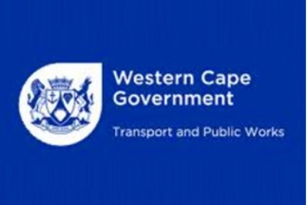 | Department of Transport and Works | R91,219,993.00 | N1 Street lighting: Koeberg & Old Oak Interchange: Phases 1, 2 & 3
2 |  | WBHO Construction | R81,210,696.00 | Cape Town Container Terminal: Coastal berth & electrical works
3 |  | Calgro M3 Holdings | R35,205,007 .00 | Scottsdene Housing Project: Bulk Supply & Internal Reticulation: Pockets
4 | 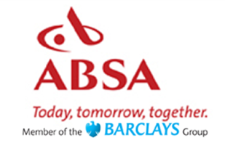 | Absa Bank | R34,704,633.00 | Lerato Park, Kimberley:Internal Elec Eng Services: Phase 1
5 |  | Nyandeni Local Municipality | R 31,325,437.00 | Ngqeleni Phase 3, Phase 2: Electrification
6 |  | Eskom | R30,431,410.00 | Butterworth Ncorha 66kv Line
7 | 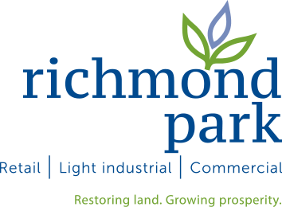 | Richmond Park Development (Pty) Ltd | R29,448,918.00 | Richmond Business Park: Construction of Electrical Bulk Services
8 |  | WBHO Construction | R26,602,133.00 | Val de Vie Lifestyle Estate, Paarl: Electrical Reticulation.
9 |  | Calgro M3 Holdings | R23,102,656.00 | Belhar CBD Development: Phase 1, Erf 21493: Electrical Reticulation
10 |  | Ingquza Hill Local Municipality | R20,000,000.00 | Electrification of Tshonya villages - Phase 1

